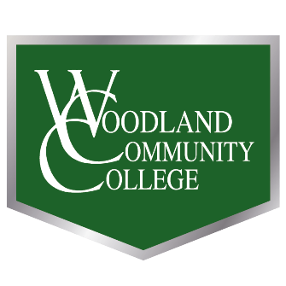
Resolution to Honor Dr. Matt Clark
  - Woodland Community College Academic Senate
Whereas, Dr. Matthew (Matt) Clark served on the WCC Academic Senate every year since the college became accredited in 2008, including three terms as President (2013-2018, 2022-2024); and
Whereas, Matt showed unparalleled leadership in his 32 years of service to YCCD, stepping up whenever he was needed but also happily allowing others to grow into leadership positions, leaving a lasting impression on the many faculty that he mentored; and
Whereas, Matt was the first tenure-track Professor of Mathematics and Statistics, a co-founder of the Writing and Math Center (WAM), and a fierce advocate of academic excellence and support for all students; and
Whereas, Matt inspired many students to love math through his engaging and thoughtful teaching, his endless supply of math pun shirts, and his famous Pi Day pie giveaways to students, staff, and faculty at all 3 campuses; and
Whereas, Matt’s warm heart was reflected in his ability to wear t-shirts and shorts in all weather, making him a style icon who was instantly recognizable from across campus; and
Whereas, Matt’s school spirit was reflected in everything from his shoelaces to his enthusiastic support for the WCC soccer team (even after an epically long board meeting); and
Whereas, Matt’s level-headedness and steadfast reliance on data (even when it irritated people who disagreed with him) was balanced with his sense of humor and wit that could be counted on to liven up boring meetings or lighten up intense ones; and
Whereas, Matt practiced small and large acts of kindness to his colleagues on a daily basis, from purchasing someone’s favorite color pens to personally funding student events; and
Whereas, Matt always supported the Ag Department by attending the first week of plant sales, getting a ton of plants, killing them by accident during the week, then attending the second week to replace them all; and
Whereas, Matt walked around the campus weekly in his trademark Converse sneakers to make sure folks were happy and taken care of, and visited the Lake Campus often enough to have an office with his name on it there; and
Whereas, Matt made time for every person who wanted to talk to him or needed his support, even though he was first and foremost a dedicated husband, father, son, brother, and grandfather with an amazingly full life and loving family; and
Whereas, Matt was known as a trusted colleague and friend with tremendous integrity, transparency, and authenticity who looked for the good in everyone and believed in the potential of his students, colleagues, and Woodland Community College;
Therefore, be it resolved, that the WCC Academic Senate acknowledges and commemorates Matt Clark’s lasting impact on Woodland Community College; and
Therefore, be it further resolved, that WCC Academic Senate continue his legacy by nurturing and mentoring new faculty leaders in his honor and memory.
On behalf of the 2024-2025 WCC Academic Senate,

Professor Aree Metz, WCC Academic Senate President
Adopted by acclamation on March 14 (Pi Day), 2025

